[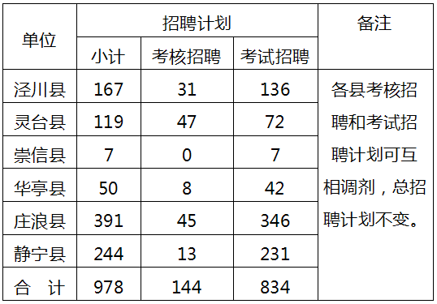](http://www.pljyw.net/data/attachment/portal/201801/12/120103dq8g6k8xogz656qg.png)